- Introduction

Towards the end of 2021, Age UK polled older people to better understand the impact that the cost of living crisis would have on them, with 23% of the most disadvantaged older people telling us they felt the increases in costs would have a severe impact. Specifically, concerns surrounded being able to pay for essential items and household bills and as a result being pushed into debt, living in cold houses, eating less and cutting back on social activities with friends and family to survive.

To support Local and National Partners in sustaining and extending the reach of their vital service provision during this cost of living crisis, in December 2022, Age UK launched a Cost of Living Response Fund Programme. £5 million was awarded to all 126, out of a possible 132, Partners that applied for the fund, which equates to 95% of the Network. Partners applied for a maximum of £40,000 to support with up to five types of intervention: Information & Advice, Home Support, Meal Provision, increasing access to Social Support/Physical Activity, increasing access to Day Centres. There is a breakdown of how the funding was used across these interventions below.

- Key findings

  - Across the year from March 2023-March 2024, this Programme has directly supported 94,912 older people across 405,986 interactions within the five intervention areas.

  - 10,141 people were supported to identify and apply for all the benefits they are entitled to. This support has led to £848,105.25 of weekly benefits being identified, annual benefits identified totalled £37,237,654.07.

  - Most Partners applied for funding to support their Information and Advice (I&A) services (54/122). This suggests there is a need for more funding for this type of service in comparison to the other intervention areas. Feedback from Partners support this, identifying more complex cases and longer waiting lists as current challenges in supporting older people with accessing their benefit entitlements as well as providing other support through I&A services.

  - Most clients accessed Attendance Allowance (61%) claiming an average weekly amount of £90. However, this funding also allowed Partners to focus on supporting older people to claim benefit types such as Pension Credit and Council Tax which are less covered through other funding streams. These benefits are means tested and aim to support those who need it most.

  - Data shows that clients supported by the funding in more deprived areas, identified a higher weekly benefit amount than those in more affluent areas. Despite this there is a higher percentage of people claiming benefits in more affluent areas. This suggests that while people in more deprived areas may be entitled to more, they may not be claiming all they are entitled to.

  - 8,467 people have received Home Support services such as cleaning, shopping, and gardening, assisting individuals to stay safe and independent in their homes. This equates to 74,724 hours of support delivered either at reduced or a completely subsidised cost.

  - 57,767 meals were delivered to 3,098 older people across the Programme, supporting people to have access to hot and nutritious meals. In comparison to the other intervention areas, meals were delivered to more older adults in the most deprived areas at 61.27% of older adults who were supported, residing in the 50% most deprived areas and 35.06% residing in the 30% most deprived areas of the country.

  - Network Partners have supported 20,189 older people to take part in 102,031 hours of Physical and Social Activity. Just a few examples of services being delivered are ‘Music in the park’, coffee mornings, community helpers, befriending, art on zoom, seated exercise, and sensory stimulation/gentle movement.

  - 17,598 older individuals have attended 283,427 hours of support at Day Centre activities such as crafts, digital inclusion, bingo, ‘Knit and Natter’, choir, lunch clubs, and warm hubs.

  - Feedback from Partners highlight their gratitude for this financial support from Age UK National at a time where they were dealing increases in overhead costs, losses of funding as well as managing longer waiting times and more complex cases. Partners report they are continuing to face these types of issues.

- Distribution of Intervention Delivery

Due to Partners merging or applying to deliver their Programmes jointly, we received 122 sets of data. The data below covers the period from the start of delivery (February/March 2023) to March 2024 with data from all 122 Partners.

- 54 Network Partners delivered Information & Advice (I&A).
- 35 Network Partners used the funding to increase attendance at Physical or Social Activity sessions.
- 33 Network Partners used the fund to increase attendance at Day Centres.
- 36 Network Partners delivered Home Support.
- 23 Network Partners delivered Meal Provision.
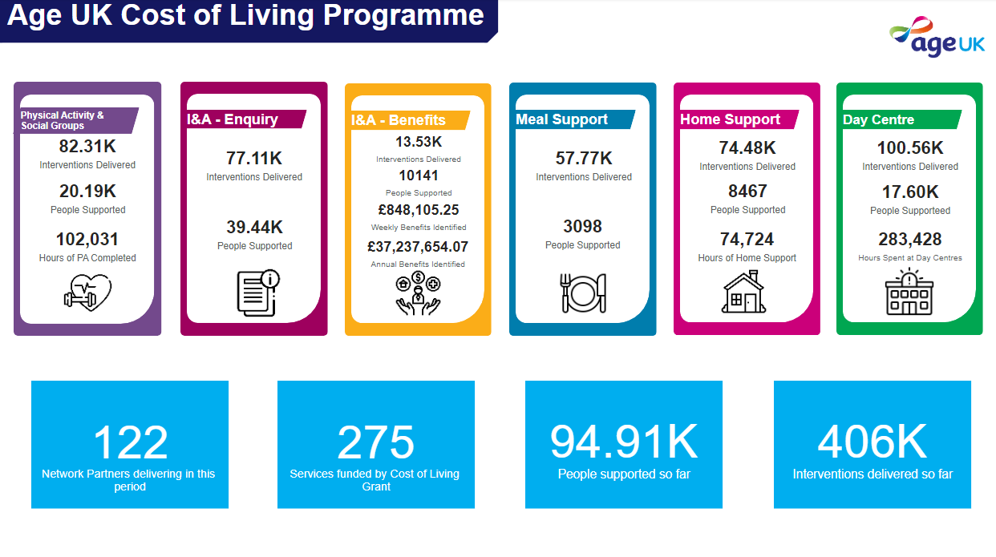

  - Information and advice (I&A)

Across the Programme, Network Partners have delivered 77,110 general enquiry interventions through their Information and Advice services supporting 39,435 older adults to access extra resources and support available in the community.

Additionally,13,526 benefit enquiry interventions were carried out supporting 10,141 people to ensure they are accessing all the benefits they are entitled to. This support has led to £848,105.25 of weekly benefits being identified, annual benefits identified equalled £37,237,654.07.

Most clients accessed Attendance Allowance (61%) claiming an average weekly amount of £90. The next most accessed benefits were for Pension Credit (9.5%) and Council Tax benefit (9%) accessing £64 and £25 respectively per week. A breakdown can be found in Appendix A.

“The Attendance Allowance has made life a lot easier I can afford taxis, a chiropodist, and it helps me with trips to the hospital. These things are not cheap in life, and it has helped me so much.”

“I'm in shock I can't believe I have heating and hot water for the first time in two years, it's going to make such a difference to my life, my health, my mental health, it already has. Thank you so much to everyone that has helped me”

When looking at the percentage of people claiming each benefit type, there is a higher percentage for clients supported by the Cost of Living Response Fund claiming Pension Credit and Council Tax benefit than through some of our other funded Programmes. This tells us that the funding through the Cost of Living project has supported Partners to focus on helping to uplift client’s income for those who need it most in areas that may not be covered in as much detail through other funding streams.

When comparing data from Partners who were funded by the Cost of Living Response Fund to those who were not funded, we can see a slight increase in the average number of issues that each older person was supported with. This could support the idea that Cost of Living Partners were able to focus on a more holistic approach to delivering their Information & Advice services than those who didn’t receive the funding, however more evidence is needed to support this

3.2 Information and Advice support across Gender

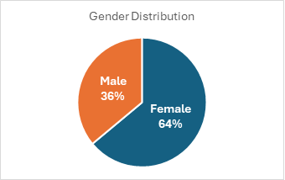
Of the gender data we have available, 64% of people who contacted Information & Advice services for support funded by Cost of Living funding were female, compared to 36% who were male. 12% of females were below 65 years old, 48% were between 65-80 years old and 40% were over 80.

46% of women contacted Information and Advice services for support with understanding and accessing benefits with 10% looking for help with community care and Age UK services. 53% of men got in touch for support with benefits and 8% had enquiries around health conditions and community care.

Enquires around support for Family and Personal reasons showed the biggest gender difference with 74% of those enquiries being made by women, followed by social and leisure activities and other Age UK services.
3.3 Information & Advice support across Age

Seeking support for understanding and accessing benefit entitlements made up the highest percentage of enquiries across all age groups, with 43% of Under 65s, 59% of ages 65-79 and 53% of those over 80 contacting Information & Advice services for help. Please see a further breakdown of the types of issues services were contacted about by age in Appendix B.

3.4 Information & Advice across Areas of Deprivation

London and the East of England have the highest average weekly benefit amount received by region, at £129 and £107 being accessed by older adults supported by the Cost of Living Funding per week. Age Northern Ireland has the lowest average weekly amount accessed at only £22. See breakdown in Appendix C.

When looking at average weekly benefits identified by areas of deprivation, we can see that the higher the deprivation, the higher the amount of average weekly benefit is identified per person, See Appendix D.
However, there is a higher percentage of people claiming benefits in the least deprived areas, which suggests that while people in more deprived areas may be entitled to more, they may not be claiming all they are entitled to. This could point to a need to focus on working in areas of high deprivation to target those older people who are not claiming their full benefit entitlements.

- Home Support and Meal Provision

Across the Programme, 8,467 people have received Home Support services such as cleaning, shopping, and gardening, assisting individuals to stay safe and independent in their homes. This equates to 74,724 hours of support delivered either at reduced or a completely subsidised cost. Of the data we had available this was an average of 14 hours of support delivered per older person.

Additionally, 57,767 meals were delivered to 3,098 older people through the Programme, further supporting people to stay in their residence and have access to hot and nutritious meals. On average Partners reached 107 older people, delivering 1,992 meals per Partner and on average 19 meals per older person.

“We are offering a 50% discount to those on a low income which has enabled people who wouldn’t be able to afford to access the service the help that they need. In circumstances where the client is on a low income, and they are awaiting the outcome of a benefit check we give a 100% discount until the benefit is awarded. This is a new service established in April in Herefordshire and referrals are increasing.”

“We have been able to provide a regular hot meal to the attendees of the day care centre and we are looking to expand this across more days during the winter months when there will be more need.” not

- Age UK Herefordshire & Worcestershire

- Increasing Attendance at Social/Physical Activities and Day Centres

Network Partners have supported 20,189 older people to take part in 102,031 hours of Physical and Social Activity. Just a few examples of services being delivered are ‘Music in the park’, coffee mornings, community helpers, befriending, art on zoom, seated exercise, and sensory stimulation/gentle movement.

On average each Partner provided 3,092 hours of activities for older people. This is the equivalent of, on average, 128 days of support to 470 older people per Partner and for an average of 5.6 hours per person across the Programme. This support covered 43,413 physical activity interventions and 38,644 Social Activity provided interventions

Across the Programme 17,598 older individuals attended 283,427 hours of support at Day Centre activities such as crafts, digital inclusion, bingo, ‘Knit and Natter’, choir, lunch clubs, and warm hubs.

This works out on average, as 227 days’ worth of attendance to 338 people per Partner, for 16.1 hours per person.

“We never run out of things to talk about at the lunch table, I often just enjoy listening to all the chatter going on.”

“I always have a good day when I've been to the centre.”

“We’ve just become good friends…….and I look forward to Fridays. It’s made a difference to my life. I can’t thank you enough.”

“I lost my Partner recently. This was a lifeline really, to keep sane, to get out of the house to mix with people. The choir does lift you, you get out, you mix, and our choir leader is so good.”

“I come for company and a natter. I have no family. It’s a great place for networking and finding out lots of information, also convenient that it’s a ‘drop in’, so you don’t feel guilty if you’re not here every week”

“I come for company and a natter. I have no family. It’s a great place for networking and finding out lots of information, also convenient that it’s a ‘drop in’, so you don’t feel guilty if you’re not here every week”.

- Demographics across all five interventions

Of the 94,912 older people supported across the programme, gender data was available for 72.1% (68,433).

35.3% (24,175) identified as male, 64.6% (44,225) identified as female, and 0.05% (33) identified as another gender identity (including transgender, non-binary, and other gender identities).

Of the 94,912 older people supported, age data was available for 41.1% (38,989).

The average age was 75.9, and the median age was 78. Please see graphs in Appendix E.

Age across the four non I&A intervention areas
Average age was similar across the four non I&A intervention areas with only 1.7 years separating Home Support, with an average age of 78.98 years and Meals with average age of 76.64 years. However, the distribution of the ages of people supported varied between Partners.
Intervention | Average Age | 69 or below | 80+
Day Centre | 78.41 | 16.15% | 48.02%
Home Support | 78.98 | 17.33% | 52.03%
Meals | 76.64 | 22.24% | 49.39%
Physical and Social Activities | 78.34 | 20.15% | 38.18%

Where data was available, Physical and Social Activities funded by the Cost of Living Response Fund supported fewer people over the age of 80 at only 38.18% accessing this type of support in comparison to the other intervention areas which all had close to 50% of their participants aged 80 or older.
Physical and Social activities had a quarter (25.47%) of clients in the age range of 75-79, this was the largest group amongst the four intervention areas.
6.1 Index of Multiple Deprivation Data (IMD) for the four non I&A Intervention areas
When looking at the individuals reached through the four non-I&A interventions, where a postcode was provided and therefore IMD data was available, Meal Support was shown to have reached more people in the most deprived areas with 61.27% of older people supported living in the 50% most deprived areas and 35.06% living in the 30% most deprived areas.
Comparatively, Physical & Social Activity (57.96%), Home Support (59.25%) and Day Centre (57.16%) interventions reached more people in the 50% least deprived areas.

Intervention | IMD
 | 1-5 | 6-10 | <=3 | >=8
Day Centre | 42.84% | 57.16% | 21.78% | 38.11%
Meals Support | 61.27% | 38.73% | 35.06% | 20.61%
Home Support | 40.75% | 59.25% | 21.65% | 40.61%
Physical & Social Activities | 42.04% | 57.96% | 21.50% | 34.57%

- Feedback from Partners

Network Partners have faced many challenges to offer older people support in the past few years; we have heard about staff shortages, increases in overhead costs, losses of funding as well as managing longer waiting times and more complex cases. Despite this, Partners have continually offered high quality, holistic support which is making a huge difference to people’s lives.

“We have mostly used the funds to support our benefit work, with some going towards our general support to those struggling financially (issuing foodbank vouchers, hardship grants, carrying out benefit checks). Waiting lists for support via welfare rights – enabling us to double our resources. However, the waiting time is still quite long about 4 months at the moment unless under special rules or there is a deadline to return the form. We are also giving greater priority to over 90 year olds.

We have seen new clients requesting benefit checks due to the cost of living crisis, however after checking their position they are already getting all their entitlements. Some benefit decisions are taking a long time to come through, meaning that clients are having to struggle financially for longer.”

- Age UK Norwich

Unfortunately, we are still hearing from Partners that the impact of covid and the cost of living crisis continues to affect older people in their communities. All 53 Partners who provided feedback via an end of Programme Survey all either strongly agreed or agreed that their clients are still being impacted by the cost of living crisis.

“Older people continue to be affected by the impact of the pandemic. Older people have told Age NI about the financial pressures they are experiencing due to increases in the cost of living. Callers to Age NI's Advice Service have talked about being anxious and fearful about rising energy costs, food costs and other costs, and not wanting to put their heating on. Older people continue to be cautious about participating in social activities, adversely impacting on their wellbeing”

- Age Northern Ireland

Feedback around the Cost of Living funding and its impact has been extremely positive, and Partners have highlighted their thanks for the financial support from Age UK National across this difficult time.

“It was a godsend at a key moment for us. It allowed us to be confident about going forward without the need for "that meeting" where we would have to make decisions about possible redundancies or reduction, or even ceasing a service. We are proud that we have got through the whole of Covid without having to do either of those things and this fund played a key part in offering some stability over a fairly long period when we needed time to recover. I would ask that the value of this be considered in the future.”

- Age UK Reading

“We were really grateful for the Cost of Living funding. It made a huge difference and was a substantial amount of money, which helped us to keep running. Similar funds in future would be very much appreciated.”

- Age UK Hammersmith & Fulham

“Age UK Plymouth would like to extend our thanks for the hard work in securing and distributing this funding. This has helped us to assist so many clients and continue to provide the much needed I&A service.”

- Age UK Plymouth

7.1 Feedback Survey

All 122 Network partners taking part in the COLRF were invited to complete an end of Programme feedback survey, we received 53 responses, giving a response rate of 43%.

Most services funded by the COLRF were reported as funding existing services, with 72% of responses indicating the grant provided budget relief. When asked how these services will continue 27% of Partners highlighted that external grants would be used, 25% stated costs would be absorbed internally and 20% responses stated that fees to clients would be increased. ‘other’ responses generally cited that the service would not be continuing, staffing reductions or that internal funding would be used until external funding could be sourced.

94% of Partners reported their agreement or strong agreement that their organisation was still being impacted by the Cost of Living crisis. 100% of responses either agreed or strongly agreed that their clients were still being impacted.

85% of Partners indicated that the main challenge faced across the last year was funding. Other challenges included increasing loneliness and isolation of older people, lack of transport, minimum wage increase and demand exceeding capacity
When asked what challenges Partners expect to face in the coming year, there are some notable differences in responses. Funding is still the most cited challenge, but there is a 7% increase from 85% to 92%. Waiting lists and complex cases sit jointly at 60%, however this is a 4% decrease for waiting lists and a 6% increase for complex cases. Lack of volunteers decreased by 6% to 45% and organisation restructure rose from 4% to 25%.

The largest increase in response was for staff illness/turnover, which was not cited as a challenge for the previous year but is cited as a challenge for the coming year by 32% of partners. Responses of “other” to this question cited common themes such as an inability to raise staff salaries, an increased demand for services which exceeds capacity, a loss of income from Local Authority grants and rising utility bill costs.

The results of this survey show that the Cost of Living programme was impactful, and the funding strongly appreciated, allowing partners to continue to offer services to their clients as well as delivering new services alongside existing services and development of new services.

Appendices

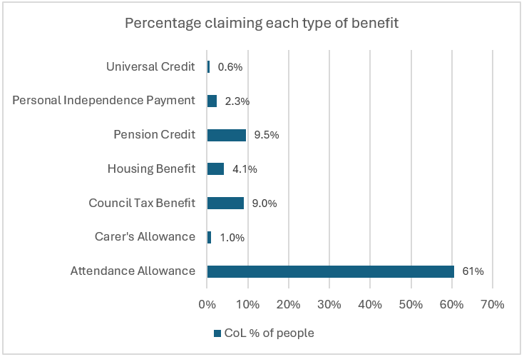
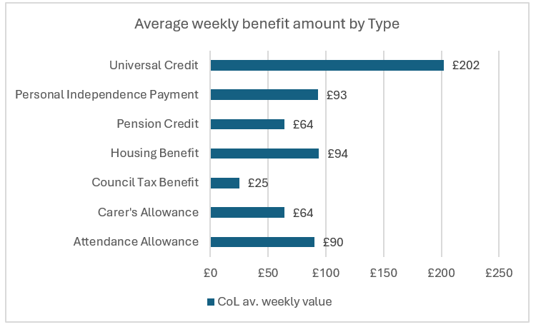
Appendix A

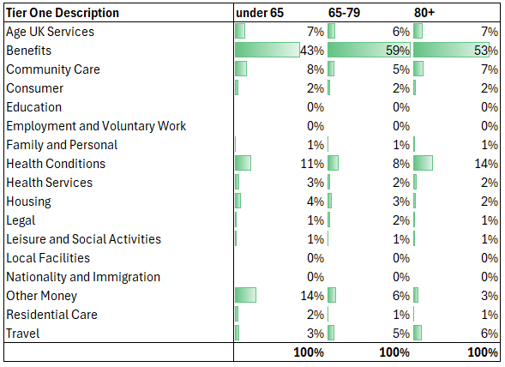
Appendix B

Appendix C

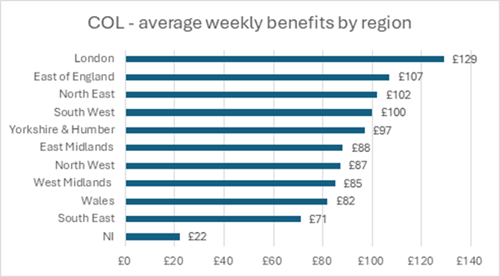

Appendix D
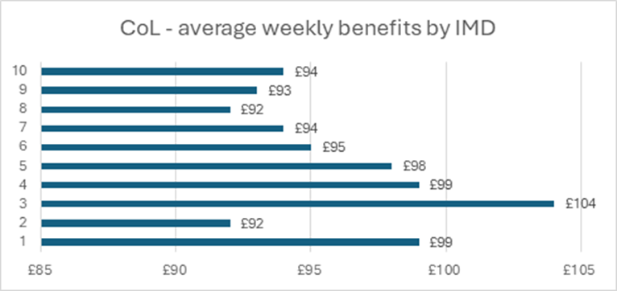

Appendix E
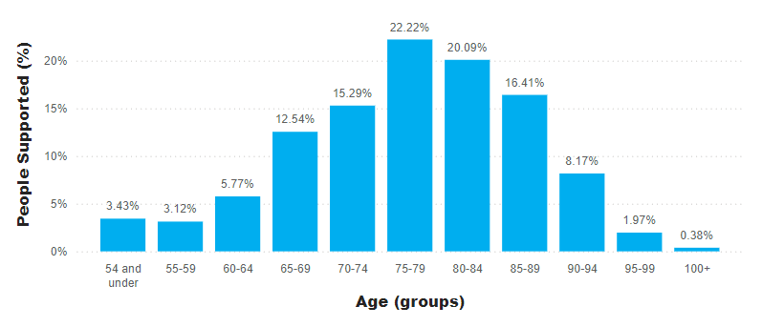
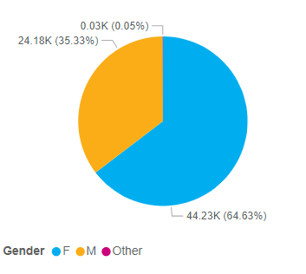

if an older person has been supported by more than one intervention; they have been counted more than once. Therefore, the total number of older people reached in this figure is less than when each of the interventions are totalled.
One Partner was given a two month extension to complete their Programme
Time data was available for 33 of 43 partners
IMD relates to the Index of Multiple Deprivations, which relatively rank each small area in England from most deprived to least deprived. In this example the IMD decile are being used which divide the small areas into deciles of 10%.

