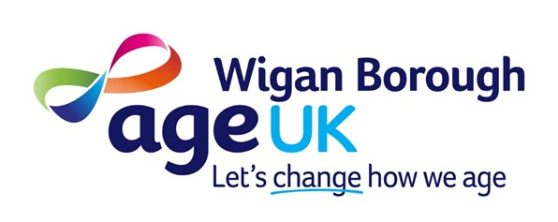

JOB DESCRIPTION

Post: Handyperson

Responsible to: Assistant Team Leader Handyperson Service

Key Relationships: Older people living in their own homes, other staff working in Age UK Wigan Borough

Salary: £11.50 per hour

Hours of work: 37 hours per week

Note:
- This post is subject to basic Disclosure & Barring Service (DBS) disclosure procedures.
- This post involves handling heavy items, with suitable equipment, and requires postholders to be able to manage the physical requirements of the role.
- This post requires a full driving licence and willingness to have responsibility for a van provided by Age UK Wigan Borough, including parking it out of hours.

Purpose of this Post

The Handyperson service provides small jobs in the homes of older people across Wigan Borough, with the aim of helping older people to live as independently as possible. The types of job involved are outlined in the Handyperson Task List (not exhaustive).

Key Duties & Responsibilities

- To provide a high-quality Handyperson Service to older people across Wigan Borough.

- To ensure you have up-to-date knowledge of services available to older people and to identify when older people need other relevant services. To report this to the Support at Home Team Leader so that referrals can be made.

- To assess and complete a range of tasks in a timely way and to an agreed standard (see Handyperson Task List).

- To collect payments using a variety of methods when required, in accordance with Age UK Wigan Borough’s Financial Control Procedures.

- To have responsibility for a van provided by Age UK Wigan Borough, including for parking it safely out of hours.

- To manage deliveries to the store and purchase stock for customers.

- To work in a flexible way, ensuring that appointments are met and reporting back any schedule changes to the Assistant Team Leader Handyperson Service.

- To complete appropriate paperwork and/or digital recording of work ensuring that all job sheets and other records are in accordance with the policies and guidelines of Age UK Wigan Borough.

- To maintain accurate service user information ensuring confidentiality.

- To provide office support to the Assistant Team Leader Handyperson Service when required.

- To support the organisation to fulfil its responsibilities under Health and Safety. You may be asked to take on roles such as First Aider, Health and Safety representative for which appropriate training will be given.

- To work with volunteers who support the service. A..ppropriate training will be given.

- To participate in Age UK Wigan Borough promotional events as required.

- To work within all the guidelines, policies and procedures as set out by Age UK Wigan Borough.

- To attend Induction, Training and any Staff Meetings as and when required.

- To carry out any other duties as may be requested which are consistent with the duties and responsibilities of the post.

AGE UK WIGAN BOROUGH
PERSON SPECIFICATION – Handyperson
BASED AT Age UK Wigan Borough

Please ensure that you show how you meet each of the following requirements
when completing your application form.

 | ESSENTIAL | EVIDENCE
Knowledge and Experience

1. | Experience of work in practical settings, with a proven ability to undertake minor jobs within and outside the home environment. Gardening and decorating experience would be advantageous as would having a specific trade. | Application form Interview
2. | Experience of accurate record keeping and reporting | Application form
3. | Understanding of the challenges facing older people who wish to remain independent and living in their own home | Application form Interview
4. | An understanding of and commitment to client confidentiality | Application form Interview
Skills

1. | The ability to use computers and common office software applications, in particular Microsoft Word, Outlook and Excel | Application form  Test
2. | Ability to work unsupervised and as part of a team | Application form Interview
3. | Sensitivity to older people from a wide range of backgrounds | Application form Interview
4. | Ability to identify when older people could benefit from other services and to encourage them to agree to being referred | Application form Interview
5. | This post requires a full driving licence. You will need to drive and park the van provided by Age UK Wigan Borough | Application form  Full Driving License  Interview
General

1. | Demonstration of the Age UK Wigan Borough PRIDE values: Person-centred, Respectful, Innovative, Dynamic, Empowering | Application form Interview
2. | The ability to meet the physical requirements of the role including moving heavy items such as paving slabs (equipment provided) | Application form  Interview

Originator: Sarah Shannon Date: December 2024

