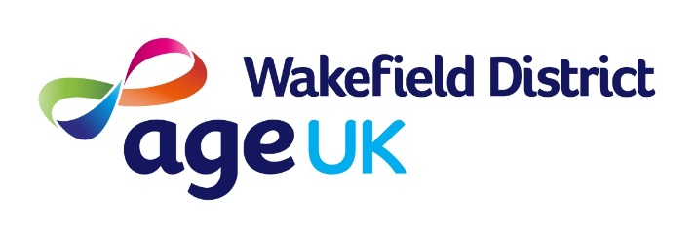

September 2024

Dear Applicant

**Job Vacancy: Community Case Worker**

Please find enclosed a Recruitment Pack, as requested, for the above vacant post within our Organisation.

If you would like any further information, please contact: **Mohammed Hussain** on **01977 552114**

Please return your completed Application Form, by email to [**jobs@ageukwd.org.uk**](mailto:jobs@ageukwd.org.uk), by post or hand-deliver (to the address below), marking your envelope ‘Confidential’, and for the attention of the HR Team.

**Closing Date: 12 noon, Sunday 29th September 2024**

Only successful shortlisted candidates will be contacted and invited to interview.

Thank you for the interest you have shown in the work of Age UK Wakefield District.

Yours sincerely

The HR Team