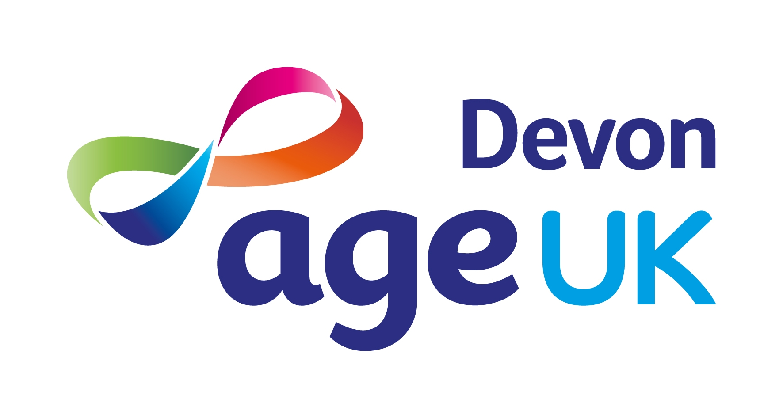

Information and Advice Statement of Service
Version 6

Who the Information & Advice Service is for?

Age UK Devon can respond to queries from people over 50 or anyone enquiring on their behalf. This includes friends, family members, carers and professionals. (If you are accessing the service on behalf of someone else, we will need the older person’s consent to give advice specific to their situation.)

How to access our service

The Information & Advice Service is available Monday – Friday 9am – 3pm. We are closed on Bank Holidays, and occasionally for staff training. When lines are closed, or all our advisors are on calls, callers will be invited to leave a message. We aim to reply to voicemail and email messages within three working days. When we are exceptionally busy it may take us longer.

By phone: 0333 241 2340

By email: infoandadvice@ageukdevon.org.uk

By post: Age UK Devon, 1 Manaton Court, Manaton Close, Exeter, EX2 8PF

Please note: we are not able to offer drop in advice sessions.

Areas we provide information/advice on

Income and welfare benefits: benefit entitlement checks for people over State Pension age; reducing household bills; information on accessing grants. We can offer home visits to help with some benefit applications.

Social care: how to access support from social services or arrange care privately; information on funding care.

Housing: housing options; finding a care home; home adaptations.

Local services: community groups and activities (run by us or other organisations); charities and support services; tradespeople.

Areas we can’t help with

We are not able to give regulated advice such as Financial, Debt, Legal and Immigration advice.

If we are not able to help or advise directly, we will always do our best to direct you to someone who can.

Although we can explain your options, we can’t make decisions for you.

What you can expect from us

Our service is:

Free: any help you have from our Information & Advice Service is free of charge, including our information guides.

Independent: we will explain your options clearly and won’t give advice which favours a particular organisation or service. We won’t recommend particular traders, including those linked to Age UK or Age UK Devon.

Non-judgemental: we will treat you with respect regardless of your age, disability, sex, gender identity, sexual orientation, ethnicity, religion, family circumstances or life choices.

Confidential: all enquiries are confidential and no information is shared with third parties without consent. All data is stored securely and in accordance with the General Data Protection Regulation. In exceptional circumstances we may need to share certain details with other organisations (e.g. adult social services if there is a safeguarding concern) without a client’s consent. For more information, please see our Data Protection Privacy Notice, Confidentiality Policy and Safeguarding Adults Policy.

Timely: we aim to respond to enquiries within three working days. This may vary in exceptionally busy periods.

What we expect from you

In return for providing information and advice we expect our clients to:

- Treat our staff, volunteers and other clients with courtesy and respect.

- Provide us with accurate information about your circumstances.

We do not charge for information and advice. Age UK Devon is a local charity and does not receive any government funding. If you are able to make a donation, leave a legacy or volunteer in one of our roles, it will help us continue to offer this service. Please ask us for more information.

Revision history

Revision date | Summary of Changes | Other Comments
May 2018 | Procedure created.
Jun 2019

Sept 2021
Jul 2023

Aug 2023

Sep 2024 | Title of safeguarding policy updated.  Revision history added.  Version number updated from 5 to 6. | Revised version uploaded to the website.  Revised procedure discussed at Team Meeting on 2/10/24 and circulated to Team with hyperlinks on 3/10/24.

