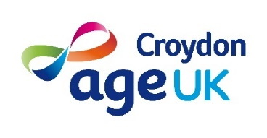

Volunteer role: Administrator- Volunteer Programme
Service: Volunteer Programme
Supported by: Volunteer Programme Officer
Location: Home or Office based- Thornton Heath CR7
Days / hours: Flexible
Time commitment: Minimum of 3 hours a week
Training: Full training and ongoing support are provided.
Expenses: We will reimburse you for any out-of-pocket expenses.

AgeUK Croydon is a local independent charity that delivers a range of services to support older people across the Borough of Croydon. We have over 85 volunteers who play a vital role in the delivery of our services.
As an Administrator for the volunteer programme, you will support the recruitment and onboarding of new volunteers. This is a wonderful opportunity to give back to your community and make a positive impact.

What will I be doing?
- Responding to volunteer enquiries and applications.
- Arranging volunteer interviews.

- Completing onboarding paperwork with new volunteers including DBS checks.
- Check-in with volunteer applicants and AUKC services during the onboarding process.

- Keeping spreadsheets and Charity Log up to date.
- Ensure mandatory training is completed by volunteers, and records reviewed regularly.
- Offering tech support to volunteers as and when needed.

Personal qualities and experiences:
- Excellent communication skills.
- Organised with good attention to detail.
- Approachable and friendly.
- Ability to handle confidential information.
- An understanding of volunteering.
- Good IT skills.

In return, you will:
- Have an induction and training
- Have regular catch-ups to support you in your role.
- Be re-imbursed for any out-of-pocket expenses.
- Join a friendly team and be supported in your role.
- Meet new people.

*This role is subject to an enhanced DBS check and 2 references.

