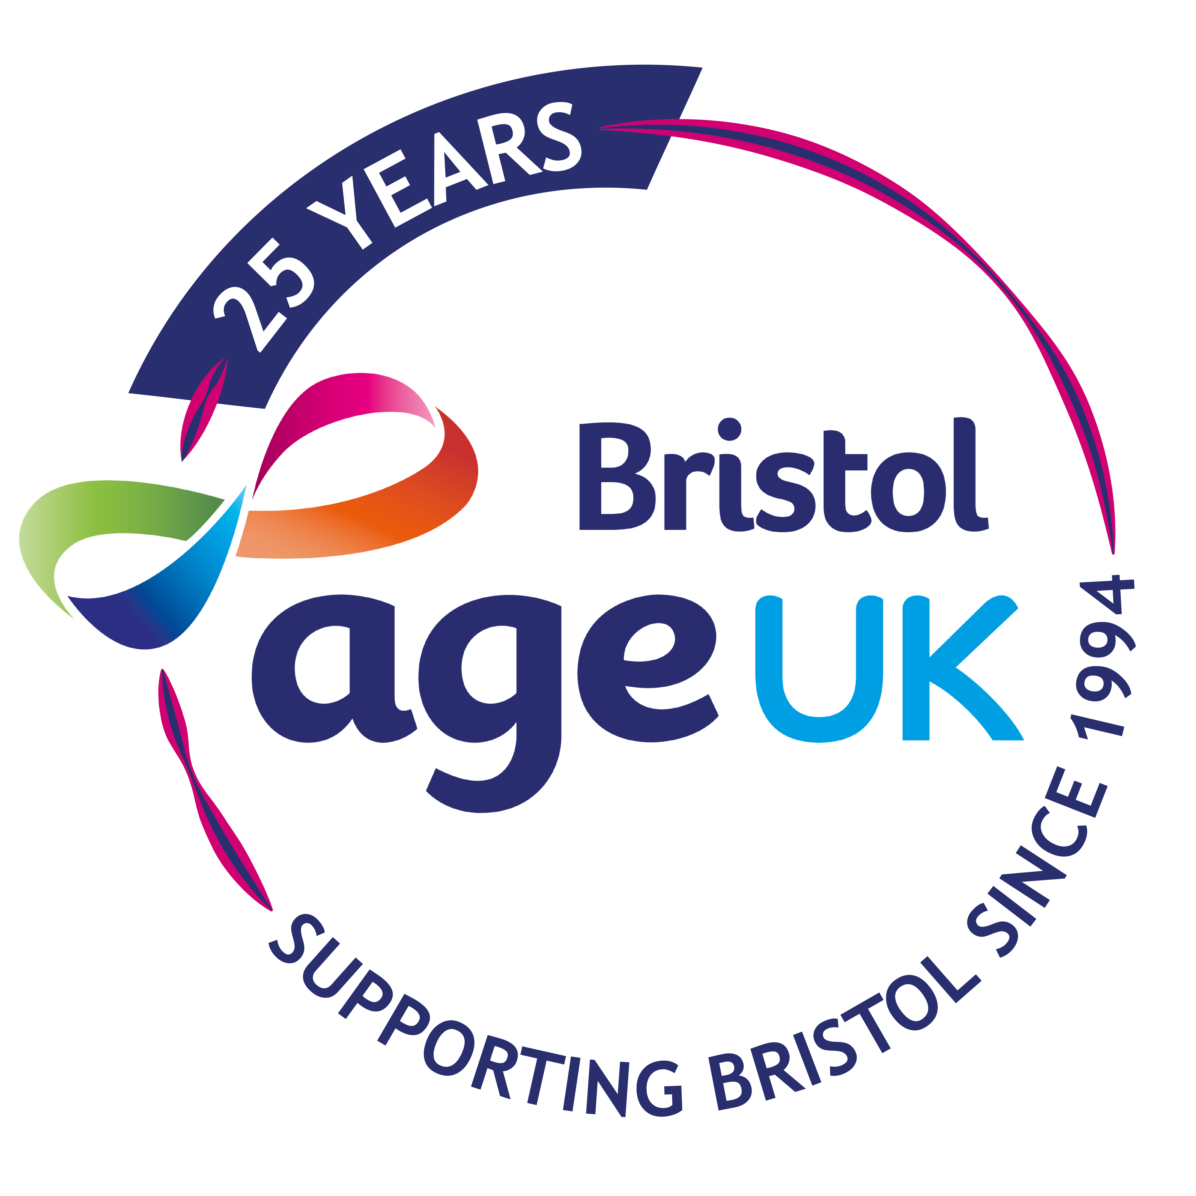
Gift Aid / Donation Form
Give a gift to Age UK Bristol to help reduce isolation and loneliness in older people.
Cheques
Please send a cheque made out to “Age UK Bristol” to:
Age UK Bristol, Canningford House, 38 Victoria Street, Bristol, BS1 6BY.
You can also donate online www.ageukbristol.org.uk.
£15 £50 Other £……..
£25 £100
Sign me up for the quarterly Newsletter - Email: ………………………………………………………………
Gift Aid Declaration
Boost your donation by 25p of Gift Aid for every £1 you donate
□ I want to Gift Aid my donation of £………….. (please complete) and any donations I make in the future or have made in the past 4 years.
I am a UK taxpayer and understand that if I pay less Income Tax and/or Capital Gains Tax than the amount of Gift Aid claimed on all my donations in that tax year it is my responsibility to pay any difference.
My details
Title ………………… First Name or initial ……………………………………………….
Surname ………………………………………………………………………….……
Home address ……………………………………………….……………….…….
…………………………………………………………..…………..
Post code ………………………………………….

Signature …………………………………………….. Date ………………………..
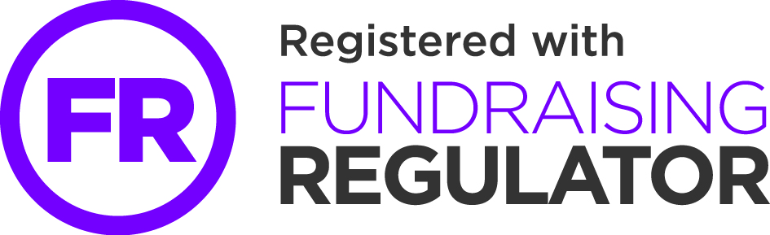
Please notify the charity if you:
□ Want to cancel this declaration
□ Change your name or home address
□ No longer pay sufficient tax on your income and/or capital gains.
• The charity will reclaim 25p of tax on every £1 you give on or after 6 April 2008. If you pay Income Tax at the higher rate, you must include all your Gift Aid donations on your Self Assessment tax return if you want to receive the additional tax relief due to you.

