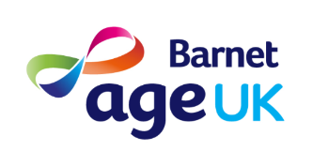

**Chef / Catering Manager**

**Exciting Opportunity to join our team!**

**Full time 35 hours per week (Mon – Fri)**

**Salary circa £30,000.00 per annum**

Age UK Barnet is a charity aiming to promote independence and wellbeing amongst older residents in the London Borough of Barnet. We currently offer a lunch service to clients with early stages of dementia who attend our Day Centres. This caters for up to 40 clients per day and we aim to offer a varied range of nutritious homecooked meals. In addition, we have recently launched our ‘Friday lunch club’ and organise and run cookery classes as part of our wellbeing services. There are also opportunities to cater for small functions when we hold these.

We are seeking to recruit an experienced chef / catering manager to oversee the catering function within our organisation across two sites. (East Finchley and Hendon) As our catering manager you will be responsible for ensuring our kitchens run smoothly and will be involved with all aspects of catering including menu planning, cooking, ordering, and ensuring food hygiene compliance across the organisation.

If you are looking for an opportunity to significantly shape our catering provision, are passionate about food and improving the lives of older people then we would love to hear from you.

Age UK Barnet is an equal opportunities employer and positively encourages applications from suitably qualified and eligible candidates regardless of sex, race, disability, age, sexual orientation, gender reassignment, religion or belief, marital status, or pregnancy and maternity.

We offer 5 weeks holiday per year, an occupational pension scheme and staff discount schemes after completion of the probation period.

For further details email [jenny.coomey@ageukbarnet.org.uk](mailto:jenny.coomey@ageukbarnet.org.uk) or telephone 0208 432 1418 please.

Closing Date 25th January 2025