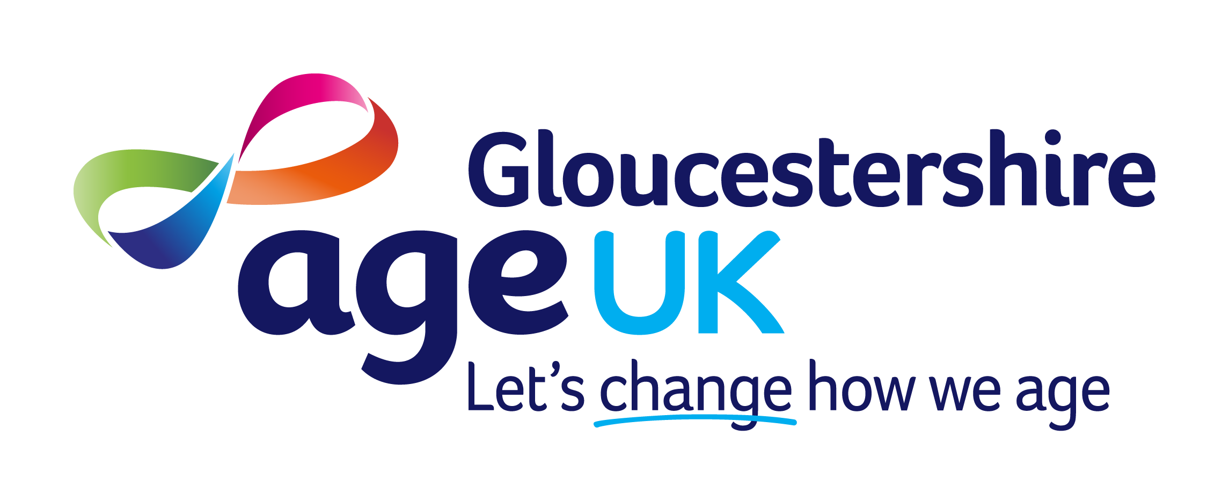
Expression of Interest Form

PRIVATE AND CONFIDENTIAL
Please fill in this form as completely as possible and return it to:

Age UK Gloucestershire
Henley House
Barnett Way
Barnwood
Gloucester
GL4 3RT

Alternatively: please email to hr@ageukgloucestershire.org.uk

PERSONAL DETAILS (please use capital letters if handwritten)

FIRST NAME |  | SURNAME
DAYTIME  TELEPHONE  NUMBER |  | MOBILE  NUMBER
E-MAIL
ADDRESS
POST CODE |  |  | CURRENT DRIVING LICENCE? |  | YES / NO
ARE YOU ELIGIBLE TO WORK IN THE UK? |  |  |  |  | YES / NO
DO YOU HAVE ACCESS TO A CAR FOR WORK PURPOSE? |  |  |  |  | YES / NO

ABOUT YOU
Please answer the following 3 questions?
- Why are you interested in working for Age UK Gloucestershire?
- Why are you applying for this particular role?
3. What skills and experience (including lived and volunteering experience) can you bring that arer relevant to the role?

The information you have given on this form is entirely confidential and will be kept for monitoring purposes only. The information is not divulged to any third party. The information is stored in accordance with our responsibilities under the Data Protection Act.

SIGNED: | DATE:

EQUAL OPPORTUNITIES

Age UK Gloucestershire is committed to developing inclusive people policies. Our recruitment and selection procedures aim to stop any unfair discrimination, whether to do with ethnic origin, disability, gender, sexual orientation, marital status, ex-offenders, religion, political beliefs, trade union activities or age.

To check that we are being successful in this and that we meet the law, we need to monitor our recruitment process. Please complete this part of the application form so that we can check whether we are, in fact, receiving applications from all sections of the community, that candidates receive fair and equal treatment at all stages and that we comply with the law.

THIS SHEET WILL BE SEPARATED FROM THE REST OF THE FORM IMMEDIATELY ON RECEIPT AND KEPT FOR MONITORING PURPOSES ONLY.

- How old are you?

16 -25 |  | 26-35 |  | 36-45 |  | 46-55 |  | 56-65
66-75 |  | 76 & over |  | Prefer not to say:

- Which of the following most closely describes your ethnicity?

Asian or Asian British |  | Mixed or Multiple Ethnic Group
Black, African, Caribbean or Black British |  | White (Any white non-British Background)
Gypsy or Irish Traveler |  | White (British, English, Northern Irish, Scottish or Welsh)
I don’t want to say
None of these represent me, I describe as:

- Which of the following most closely describes your religion/belief?

Buddhist |  | Christian |  | Hindu |  | Muslim |  | Sikh
No Religion |  | Other religion |  | Religion not stated

- Which of the following most closely describes your sexuality?

Straight Heterosexual |  | Gay/ Lesbian / Homosexual |  | Bisexual |  | Asexual |  | I don’t want to say
None of these represent me, I describe myself as:

5. Which of the following most closely describes your gender identity?

Male |  | Female |  | Transgender |  | Gender neutral |  | I don’t want to say
None of these represent me, I describe myself as:

6. Do you consider you have a disability?

Yes |  | I don’t want to say |  | No
If you wish to specify the nature of your disability,
you may do so here:

All shortlisted candidates will be invited to advise us if they have a disability and whether they require specific arrangements to be made when called for interview, or in the course of their work.

7. CRIMINAL CONVICTIONS (for posts not involving work with children and/or vulnerable adults)

Do you have a criminal conviction which is unspent?  Yes  No

Or pending against you?  Yes  No

8. CRIMINAL CONVICTIONS (for posts working with children and/or vulnerable adults)

Have you ever been convicted of a criminal offence?  Yes  No
Is the offence “spent” as defined by the Rehabilitation of Offenders Act 1974?  Yes  No

Notes: Disclosure and Barring Service (posts working with children and/or vulnerable adults)
All posts working with children and/or vulnerable adults are subject to a satisfactory enhanced Disclosure and Barring Services (DBS) check. These types of posts are exempt from the Rehabilitation of Offender’s Act normal rules. This means that for these types of posts any conviction ever received must be declared, so that the organisation can make a decision on whether a person is suitable to carry out the job for which they applied. These checks are compulsory to ensure the safety of persons to whom we provide services. A conviction is not necessarily a bar to working with the organisation but if you have answered “YES” you may, if short-listed for interview, be invited to discuss your conviction with the Interview Panel before your application can proceed.

